Oregon Ash Seed Collecting Protocol 2019
USDA Forest Service Genetic & EAB Resistance projects –
Dorena Genetic Resource Center

Richard A. Sniezko, Megan Lewien, Scott Kolpak
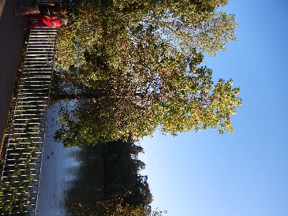
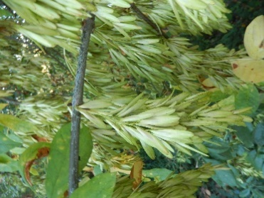
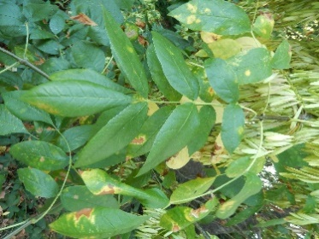
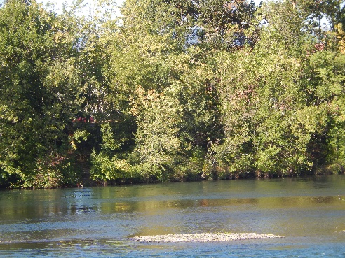

Objective: Emerald ash borer (EAB) is now as far west as Colorado. Begin proactive, measures are being taken to address community concerns on the West Coast about the future fate of the important riparian species Fraxinus latifolia (Oregon Ash) - anticipating arrival of EAB by (1) initiating the first well documented resistance testing of this species to EAB, (2) establishing a genetic conservation planting that will also serve to examine adaptive genetic variation and be a sentinel planting for the species, We believe that very little (or no) examination of genetic variation in this wide-ranging species, which occurs in CA, OR, WA & BC has been done to date, and (3) preserve the genetic diversity of F. latifolia by depositing seed collections and storing them for long-term use and preservation prior to the destruction of EAB – these collections will also be a source for future genetic studies.
Proposal: Stratify and sow seed in late 2019 from a range-wide collection of Oregon ash to (1) provide 2-year old seedlings for EAB resistance testing (send to Dr. Jennifer Koch, with the USDA Forest Service’s Northern Research Station, by summer/fall 2021), (2) to provide 1-year old seedlings for a combination field trial, conservation planting, and sentinel planting to plant in Oregon (likely on BLM’s Tyrrell or Horning sites), and (3) deposit well-documented seed samples in one to three seedbank repositories (USFS & ARS) for long-term preservation and future genetic studies.
Need: To accomplish these objectives, we are requesting assistance (in Sept/Oct 2019) from individuals and organizations throughout the range of the species to help collect and document F. latifolia seed samples. Specifically we are asking for assistance from cooperating agencies/groups, tribes or citizen scientists in obtaining seedlots throughout the species native range, from California to British Columbia, and encompassing the range of elevations under which F. latifolia naturally occurs.

NOTE: In the Oregon part of the range, we are working closely with Oregon Department of Forestry (ODF) and they will be striving to collect from 30 locations across Oregon (probably 10 trees per location).
If you are able to assist with seed collections for this project, please Richard Sniezko (richard.sniezko@usda.gov, 541-767-5716) to minimize duplication of efforts by collectors in the same geographic area.
Collection (From ODF Ash Seed Collecting Protocol)
The sampling methodology will draw on a variety of references to ensure consistency with national procedures (Knight et al. (2009), Karrfalt (2013), Karrfalt (2016)) and the National Plant Germplasm System.

Focus

- Collect from naturally occurring specimens of native origin.
- Sample widely in order to maximize diversity and eliminate and/or reduce the potential of sampling related individuals (siblings). It is recommended that samples should be separated by a minimum distance of a half mile.*
- Targeted collections seeking a diverse set of traits e.g. age, phenology, health, growth habit, etc. will also ensure the likelihood of capturing genetic diversity.
- Aim for collecting approximately 1,000 to 5,000* high-quality, intact seeds. For reference 1,000 seed is approximately one quart or a small paper lunch bag (#4 size - 5 x 3 ¼ x 9 ¾”) filled at least ½ way.
- Keep seeds from mother trees (collection trees) SEPARATE!
- Collect from trees that someone can return to in the future (for example, if resistance to EAB is found). Document well the location of the mother tree.

*NOTE: In some cases this may not be possible, and fewer seed can be collected, or distance between trees will be less (but at least 300 feet between trees), and at least several hundred seed.
Techniques
There are various ways to collect seeds. To learn more, see Methods for Collecting Ash (NRS-55). Don’t forget overhead safety (powerlines, vehicles) and PPE (hard hat, eye protection, gloves and Technu/IvyX). Basically, clip seed branches. Use tarp on ground if necessary to quickly gather scattering samaras

Timing
Seeds should be collected when the fruits (samaras) are ripe and mature, just before the seed is naturally shed from the mother tree (see separate PowerPoint document). This is when the peduncle (the “stem” of the samara) starts to turn from yellow to brown. In western Oregon, at elevations below 2,000 feet (where the majority of Oregon ash occurs), the timing of peak samara development is predicted to occur in September. BUT, ripening time may vary depending on various factors.

Quality
Before collecting, dissect a small quantity of seeds to determine quality, e.g. weevil damage, empty seeds, etc (see separate PowerPoint documents). Cut lengthwise using razor blade. Observe with hand lens. Strive to collect from trees where damage is light, and avoid collections where damage is >50%, if possible.
Collection Number System:
- Three character code for Location (example: SBP for South Branch Potomac River). You will make up these codes.
- Two digit code for mother tree (01 to 50)
- Example: SBP06 would mean collected at South Branch Potomac River, mother tree 6
- If permitted, consider attaching a tag to the tree with the ID (for future reference if future information on that tree is needed).
Labeling
- Label each bag on outside plus tag on inside using black permanent marker indicating:
  - Sample Number (e.g. SBP06 )
  - Date
  - Location description (e.g. 5 miles south of Portland, OR)
  - Collector
- Label corresponding GPS point in GPS unit identical/corresponding sample number (if using GPS unit)
- Put all bags from single mother tree inside larger paper grocery sack. Label the larger paper sack using the same labeling procedure as the smaller ones
Summary of Steps for Collection:
- Before you collect review protocol and contact richard.sniezko@usda.gov to avoid duplicating collection efforts.
- Print collection form (attached document)
- Find an area with numerous, naturally occurring (native) specimens. Obtain landowner's permission.
- Before collecting, verify seeds on targeted specimen meet quality standards. Do NOT pick seeds from ground.
- Georeference location: (Coordinates (NAD83) in decimal degree format AND directions (e.g. 5 miles north of Portland, Multnomah Co.; just west of intersection Road A and Hwy B in Boone Co.) – labeled in GPS as the tree sample number .
- Take photo of mother tree AND label with corresponding sample number with date
- Fill out collection form
- Measure DBH (inches) and height (feet) – specify units of measure if different. May approximate DBH & height if you can’t measure (but note that it is an estimate).
- Put seeds in brown paper bags to allow them to dry. Do NOT tightly pack wet/moist or green seeds in bag. Staple shut.
- Store at 65-70F with good ventilation.
- Do NOT freeze or treat seed or expose to extreme temperatures (e.g. inside closed vehicle in sun).
- Label bags with black, permanent marker (outside) and tag (inside bag): Include:
- Sample Number:
- Date:
- Location:
- Collector (and contact information):
- Fill out excel spreadsheet with detailed collection information and email with photo to richard.sniezko@usda.gov
- Arrange for shipment ASAP to Dorena Genetic Resource Center, WCottage Grove, OR - send email to Richard that a shipment will be coming (or being delivered)
Collected seed will be sent to:
USFS Dorena Genetic Resource Center
34963 Shoreview Drive
Cottage Grove, OR 97424
Attn: Dr. Richard Sniezko

Ash seed sources of info
USFS Dry Branch: https://www.fs.usda.gov/nsl/GeneticConservation_Ash.html
Ash Genetic Conservation Plan, July 2013. R.P. Karrfalt, USFS, National Seed Lab (6 pages)
Methods for Collecting Ash (Fraxinus spp.) Seeds. GTR NRS-55. 2009. Kathleen Knight, Robert Karrfalt, Mary Mason. (18 pages)
Ash Seed Collection Data Sheet. No date. USFS. (1 page)
Status Report on Fraxinus Genetic Preservation Seed Collections by ARS and FS. July 2013. Robert Karrfalt, Jeffrey Carstens, Becky Loth. (10 pages)
The Woody Plant Seed Manual. USFS Agriculture Handbook 727. July 2008. Franklin Bonner, Robert Karrfalt, Rebecca Nisley. (1,241 pages)
Collecting Ash Seed. Accessed online 2019. USDA-ARS Plant Introduction Research. NPGS Ash Conservation Project. https://www.ars.usda.gov/midwest-area/ames/plant-introduction-research/docs/npgs-ash-conservation-project/collecting-ash-seed/

References

Karrfalt, R.P. USDA Forest Service. (July, 2013). Ash Genetic Conservation Plan. Retrieved from https://www.fs.usda.gov/nsl/Fraxinus_Germplasm_Preservation_Plan_March_2010.pdf.

Karrfalt, R.P. (2016). The National Program for Long Term Seed Storage for Ash Germplasm Preservation. Gen. Tech. Rep PNW-GTR-963. U.S. Department of Agriculture, Forest Service, p. 118-125.
https://www.fs.fed.us/pnw/pubs/pnw_gtr963_046.pdf
Knight, Kathleen S.; Karrfalt, Robert P.; Mason, Mary E. (2010). Methods for collecting ash (Fraxinus spp.) seeds. Gen. Tech. Rep. NRS-55. Newtown Square, PA: U.S. Department of Agriculture, Forest Service, Northern Research Station. 14 p..

Oregon Invasive Species Council. (2015). 100 Worst List. Retrieved from https://static1.squarespace.com/static/58740d57579fb3b4fa5ce66f/t/5891577c579fb38e735f0f83/1485920126222/OISC_top100_2015.pdf.

Oregon Invasive Species Council (OISC). (2017). Oregon Statewide Strategic Plan for Invasive Species. Retrieved from https://static1.squarespace.com/static/58740d57579fb3b4fa5ce66f/t/58921d8037c581503e799427/1485970827058/Oregon_Statewide_Strategic_Plan.pdf.

Emerald Ash Borer – Readiness and Response Plan for Oregon
https://static1.squarespace.com/static/58740d57579fb3b4fa5ce66f/t/5b1ad1896d2a73a4cffcdad1/1528484258046/EAB+Plan+2018.pdf

http://owic.oregonstate.edu/oregon-ash-fraxinus-latifolia

Acknowledgments
The information above was obtain from various sources, including some of those listed above. The photos are from Oregon ash, in Eugene, Oregon, along the Willamette River, taken in August 2019 (R.Sniezko). PowerPoint Slides by R.P. Karrfalt – USFS National Seed Laboratory. Jeff Carstens (ARS) provided edits for an earlier version of the document. Wyatt Williams (ODF) shared details on their upcoming gene conservation collection.
NOTE: Coordination of seed collection is by ODF & USFS; seed will likely be stored at USFS Dorena GRC and two ARS locations (Fort Collins and Iowa State University) and used for a variety of purposes, including gene conservation (freezer storage at different facilities), EAB testing (growing seedlings), field trials, and other purposes. ARS (Jeff Carstens, USDA-ARS – Horticulture, Iowa State University) will assist with some seed processing (if there is large number of lots collected).

