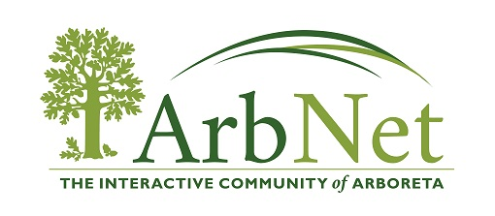

ARBNET ARBORETUM ACCREDITATION RENEWAL FORM

Level of RENEWAL requested

Please indicate which of the following levels are still met by checking the appropriate box. We encourage arboreta to use this renewal process to upgrade to a higher level, if possible. Fulfillment of these standards is self-determined by the applicant.

Current accreditation level (check one): ___LEVEL I ___LEVEL II ___LEVEL III ___LEVEL IV

Arboretum renewal level sought (check one): __LEVEL I ___LEVEL II ___LEVEL III ___LEVEL IV

FOR ALL LEVELS OF RENEWAL
- Please review the most current version of the Application (found on our website), which is attached, and confirm that all information originally submitted for your accreditation is still accurate, up to date, and meets the requirements for the level of renewal sought.
- For ALL LEVELS you do not have to fill out a new application if all your information is correct on your initial application.
- If you have significant changes (contact person, additional information to upgrade levels of accreditation) please notify us in your renewal email.

.

I have reviewed the most current version of the ArbNet Accreditation Application and confirm that all information originally submitted for accreditation is still accurate and up to date and meets current requirements. I have provided updated documentation (if needed) and/or additional information on the new application.

______ ______________________________________________________________
Date Name of authorized Title

