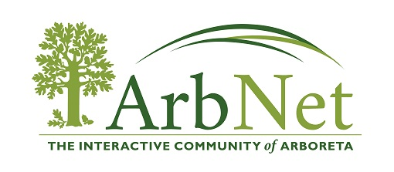

Tips to applying for a grant

Grant funding is competitive. Many agencies provide tips on completing applications so be sure read those. Check out the general tips to help you write a successful grant.
General Tips
- Read the entire grant application guide and follow instructions carefully.
- Application requirements vary across programs and industries, so look closely at the notice of funding opportunity for each specific grant program to ensure that you are addressing all the requirements and criteria for the grant program in question.
- Pay close attention to the scoring criteria and address each of those criteria to the best of your ability.
- Be sure to include any additional forms or attachments that are required.
- Pay attention to deadlines – these are usually inflexible and if you submit your application past the deadline date, it will not be considered.
- When writing your proposal, be clear and concise, establish your major points, and avoid unnecessary complexity. These points are the primary items on which the application will be evaluated.
- If provided, use the samples and checklists included in the application.
- Separate fact from opinion.

Sections of a Grant Application
Grant applications are typically comprised of several sections, as outlined below. Know what information you need to include for each section.
Project Introduction
This section is similar to an abstract and is often written after most, if not all, of the proposal is completed. It should clearly explain what you are using funds for and should be written in a way so that any reader can understand quickly and clearly what the project will deliver.
Project Justification
In this section, you should define and explain the problem that your project will attempt to address.
Some questions to answer:
- Why is it critical to address the problem now?
- What plans, studies, and data are available to identify or quantify the need?
- How will the defined population be impacted or different when the project is completed?
- What documented proof/evidence is available to support the need for your project?
- Who will your project serve?
- Are there any special circumstances to consider about your defined area/population?
- What are your organization’s needs?
Project Objectives
The objectives of your project should mirror what you are using the grant funds for in your project. Note, there is a difference between goals and objectives – goals are not measurable, whereas objectives are. Objectives are performance-related, so make sure your project objectives are realistic – they will become the criteria your project is evaluated by if you are selected for funding.
Project Timeline/Schedule
In this section, you should discuss:
- How the project will be managed by your organization;
- How project services will be delivered, and
- Who will be in charge.
Include the planned start date, activity, responsible party, completion date, milestones, and deliverables/products. You should only cover those steps/tasks that will be supported by grant funding. The schedule should be detailed and clear enough that it can give the reviewer a general understanding of what the project involves.
Project Budget
- Costs and project elements must be well-defined—explain what costs are associated with each element and what portion of the costs will be covered by each of the funding sources.
- Check the application directions or ask the grant coordinator to determine how the budget should be organized (usually in columnar form according to general accounting principles).
- Include all costs associated with capital and non-capital expenditures and all assumed in-kind services, volunteer efforts, and indirect costs.
- Only include items covered by the grant funds—do not include a miscellaneous or contingency category.
- Don’t forget that this project will take place in the future, so budget numbers should account for inflation at the time of expenditure.
- Like the project timeline, the project budget should provide enough detail that the reviewer can gain a general understanding of what the project entails.

Assemble a Grant Writing Team
This usually consists of:
- Senior-level management (who must support and sign grant applications);
- The project manager (who is the primary source of project-related information);
- A grant writer;
- An editor (otherwise unaffiliated with the project so that they can provide an independent assessment of how well the application presents the required information); and
- Finance expert(s) (to help develop a good budget)

